#### ***Introduction***

This project is focused on examining survey information, about how individuals in a university environment respond to shooters well as the training and decision making involved. Power BI will be used for the analysis to investigate how factors like age, gender, major and classification relate to aspects of participants views and encounters, with the Virtual Reality Intervention (VRI) module. The aim is to uncover trends and understandings that can help enhance campus safety measures and training initiatives.

#### ***Survey Questionnaire Overview***

The survey data consists of questions, about demographics and various sets of questions that aim to measure;

1. Comprehension of Module Content; Questions regarding the understanding gained in concepts like "Run," "Hide," and "Fight."

2. Skill Advancements; Questions about skills acquired through the module.

3. Influence on Attitudes; Questions concerning changes in attitudes towards incidents.

4. Application of Learning; Questions on how the module has facilitated learning in areas of life.

5. Overall Module Evaluation; Questions assessing the usefulness of the module.

6. Module Activities Assessment; Questions evaluating the effectiveness of module activities.

7. Course Integration Feedback; Questions gauging how well the activities in the module connected with course material.

8. Information Relevance Evaluation; Questions assessing how provided information contributed to learning.

9. Support Assessment; Questions regarding support received during the module.

**The Power BI Analysis:**

**Demographic**:

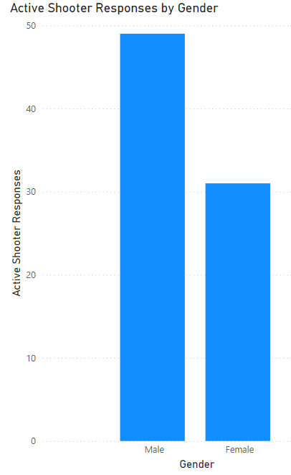  
**Fig1. Active Shooter Survey Responses by Gender**

**From Fig1. Active Shooter Survey Responses by Gender, Insight:** The number of male active shooter users is more than double that of female users, suggesting a pronounced gender difference in involvement with active shootings.

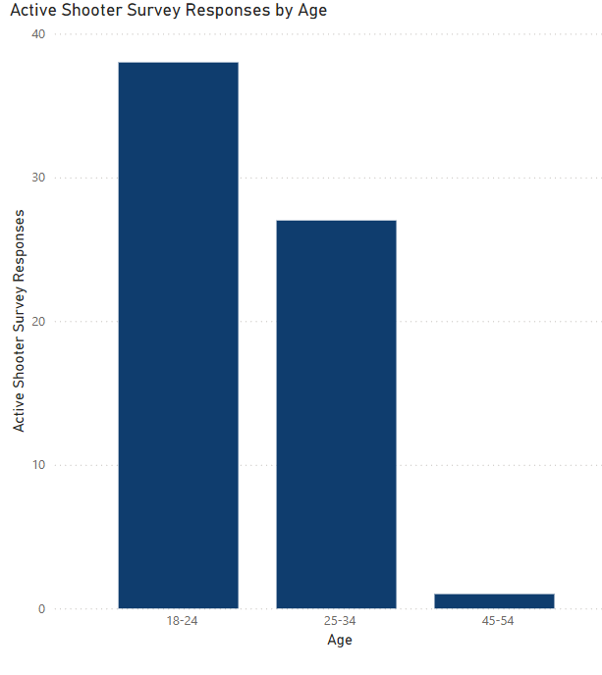  
**Fig 2: Active Shooter Survey Responses by Age**

**From Fig 2: Active Shooter Survey Responses by Age, Insight:** The 18-24 age group shows the highest number of survey responses, indicating greater engagement or concern among younger individuals regarding active shooter scenarios.

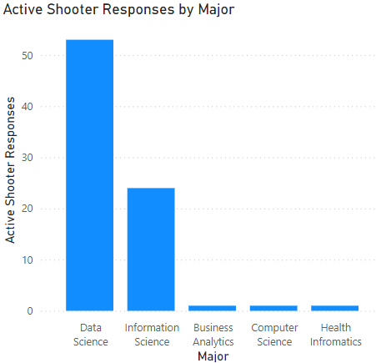  
**Fig 3: Active Shooter Survey Responses by Major**

**From Fig 3: Active Shooter Survey Responses by Major, Insight:** The Data Science major significantly surpasses other majors in the number of survey responses related to active shooter scenarios, suggesting higher engagement or interest among Data Science students or professionals.

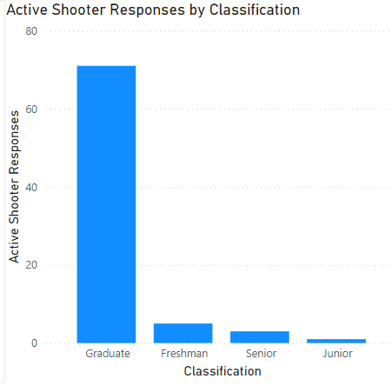

**Fig 4: Active Shooter Responses by Classification**

From **Fig 4: Active Shooter Responses by Classification,** Insight: Among the listed classifications (Graduate, Freshman, Senior, and Junior), the Graduate category has the highest number of active shooter responses, indicating that graduate students may be more engaged or concerned about active shooter scenarios.

**Conclusion:**

Graduate data science students are most concerned about active shooters; there is a gender disparity, with more male responders; young guys (18–24) are most interested in discussing active shooter scenarios. The focus should be on female involvement, age-appropriate communication to raise awareness, and safety initiatives tailored for graduate students and Data Science majors.

**Research Analysis:**

Demographic Disparities: Investigate why certain demographics (e.g., males, Data Science majors, younger age groups) are more responsive. Explore cultural, educational, or social factors.

Effective Communication: Research effective communication strategies for active shooter preparedness across different demographics.

Long-Term Impact: Study how safety awareness translates into behavior during actual incidents and evaluate the long-term impact of safety education.

## 1.1 SALG Instrument for the VRI Module:

### **Potential Graphs and Evaluations**

#### ***Overall Understanding***

**1. Graph: Average Gains in Understanding Concepts by Age Group**

* + X-Axis: Age Groups
  + Y-Axis: Average Score
  + Data: 1.1 Understanding of Run, Hide, Fight
  + Evaluation: Compare which age groups reported the highest gains in understanding each once

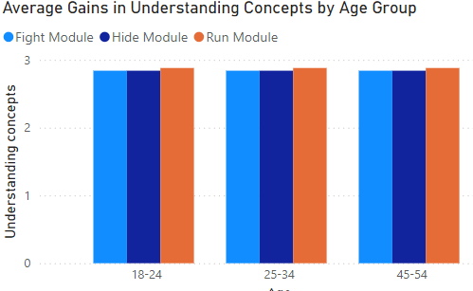

Fig 1.1.1: Average Gains in Understanding Concepts by Age Group

Based on the bar graph Fig 1.1.1: Average Gains in Understanding Concepts by Age Group, The VRI module is most effective for the 18-24 age group, with the highest gains in understanding “Run,” “Hide,” and “Fight.” Overall, understanding decreases with age, with “Hide” being the best understood concept across all groups, suggesting the need for tailored strategies for older demographics.

#### ***Skill Development***

**2. Graph: Skill Improvement Scores by Age Group**

* + X-Axis: Age Groups
  + Y-Axis: Average Score
  + Data: 2.1 Identifying patterns, 2.2 Developing programs
  + Evaluation: Assess how skill development varied among different age groups.

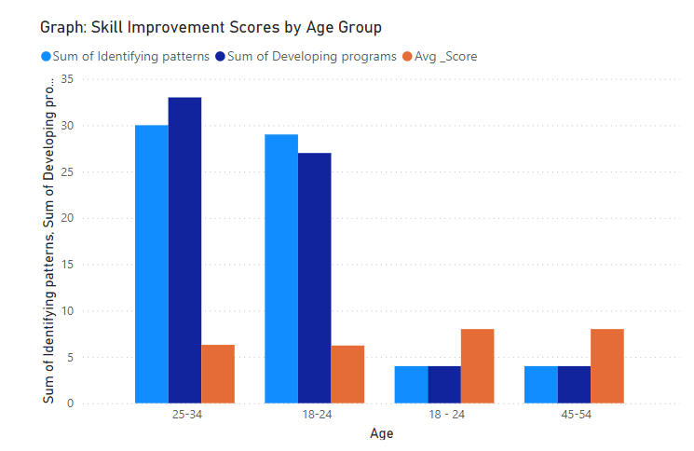

Fig 1.1.2: Graph: Skill Improvement Scores by Age Group

Based on the bar graph Fig1.1. 2: Graph: Skill Improvement Scores by Age Group, The 25-34 age group excels in both “Identifying patterns” and “Developing programs,” while the 18-24 group excels in “Identifying patterns” but struggles with “Developing programs.” The 45-54 age group scores the lowest in both areas, indicating the need for refining module content and delivery for different age groups to enhance effectiveness.

#### ***Attitudinal Changes***

**3. Graph: Changes in Attitude Scores by Age Group**

* + X-Axis: Age Groups
  + Y-Axis: Average Score
  + Data: 3.1 Enthusiasm, 3.2 Interest in additional classes, 3.3 Confidence, 3.4 Comfort level
  + Evaluation: Determine which age groups showed the most positive attitudinal changes

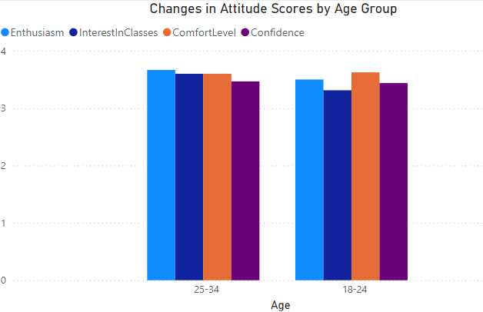

Fig 1.1.3: Changes in Attitude Scores by Age Group

Based on the provided line graph Fig 1.1.3: Changes in Attitude Scores by Age Group titled Changes in Attitude Scores by Age Group, Enthusiasm, confidence, and interest in additional classes for the module decrease with age, while comfort level with module-related programs remains constant across all age groups. These variations highlight the need to refine the module's content and delivery to better suit different age demographics and improve overall effectiveness.

#### ***Integration of Learning***

**4. Graph: Integration of Learning by Age Group**

* + X-Axis: Age Groups
  + Y-Axis: Average Score
  + Data: 4.1 Using critical thinking
  + Evaluation: Evaluate how well different age groups integrated the module's learning into other aspects of their lives.

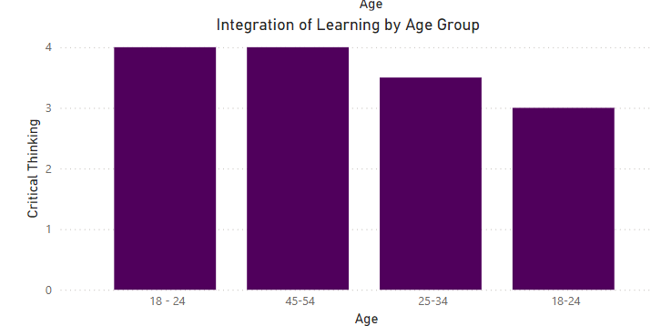

Fig 1.1.4: Integration of Learning by Age Group

Based on the provided bar graph Fig 1.1.4: Integration of Learning by Age Group titled “Integration of Learning by Age Group”, The 18-24 and 45-54 age groups excel at integrating the module’s learning into their critical thinking skills, while the 25-34 age group faces more challenges. These insights highlight the need to tailor the module's content and delivery to better address the learning integration needs across different age demographics.

--------------------------------

#### ***Gender:***

#### ***Bar Chart: Average Understanding of "Run," "Hide," and "Fight" by Gender***

**5.Data Setup**:

* + **X-Axis**: Gender
  + **Y-Axis**: Average Score
  + **Values**: Q1.1.1 (Run), Q1.1.2 (Hide), Q1.1.3 (Fight)
  + **Legend**: Question Type (Run, Hide, Fight)

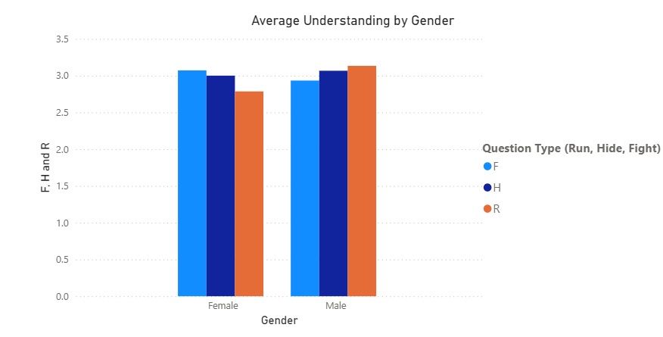Fig 1.1.5 Average Understanding of "Run," "Hide," and "Fight" by Gender

Based on the bar chart Fig 1.1.5 Average Understanding of "Run," "Hide," and "Fight" by Gender, both genders have nearly identical average scores for understanding how to “Run.” However, there’s a noticeable difference in understanding when to “Hide” or “Fight,” with males showing slightly higher average scores for both actions compared to females.

#### ***Stacked Bar Chart: Distribution of Enthusiasm for the VRI Module by Gender***

**6. Data Setup**:

* + **X-Axis**: Gender
  + **Y-Axis**: Response Count
  + **Values**: Q3.1 (Enthusiasm)
  + **Legend**: Response Scale (e.g., 0-5)

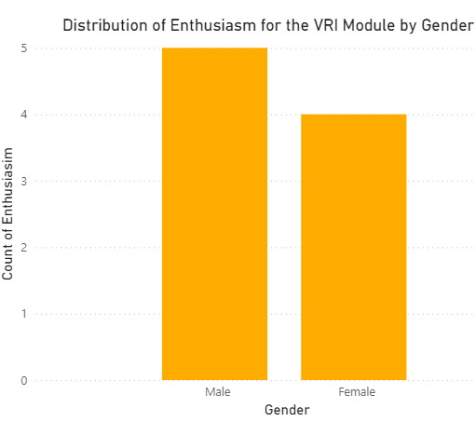

Fig 1.1.6: Distribution of enthusiasm for the VRI Module by Gender

From the chart in Fig. 1.1.6: Distribution of enthusiasm for the VRI Module by Gender., it appears that males have a higher count of enthusiasm compared to females for the VRI Module.

#### ***Pie Chart: Proportion of Gender Responses to Confidence in Understanding the VRI Module***

**7. Data Setup**:

* + **Values**: Count of responses to Q3.3 (Confidence)
  + **Legend**: Gender

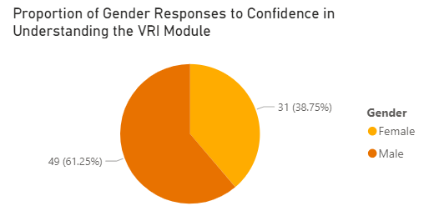

Fig 1.1.7: Confidence in understanding the VRI Module by Gender

The pie chart, Fig 1.1.7: Confidence in understanding the VRI Module by Gender illustrates the proportion of gender responses regarding confidence in understanding the VRI (Virtual Reality Interaction) Module. Among the participants, females account for 61.25% (49 responses), while males represent 38.75% (31 responses). This visual representation highlights a higher female engagement in expressing their confidence levels.

8. Response Distribution by Major: Show the distribution of responses for each question within each major.

- X-Axis: Major

- Y-Axis: Response Count

- Legend: Response Options (e.g., Scale 0-5 for Q3.1)

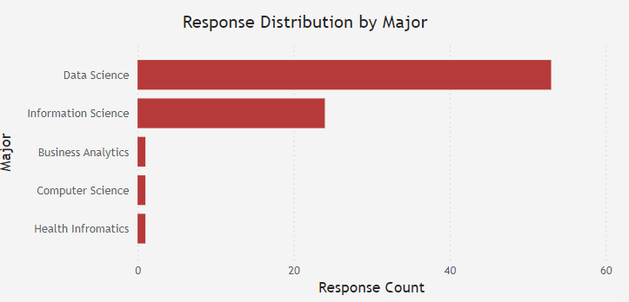

Fig. 1.1.8: Survey Response Distribution by Major

The chart Fig. 1.1.8: Survey Response Distribution by Major indicates that Data Science has the highest response count, followed by Information Science. Business Analytics has fewer responses, while Computer Science and Health Informatics have minimal participation.

9. Proportion of Major Responses: Display the proportion of responses from different majors for specific questions.

- Example: Confidence

- Values: Count of responses

- Legend: Major

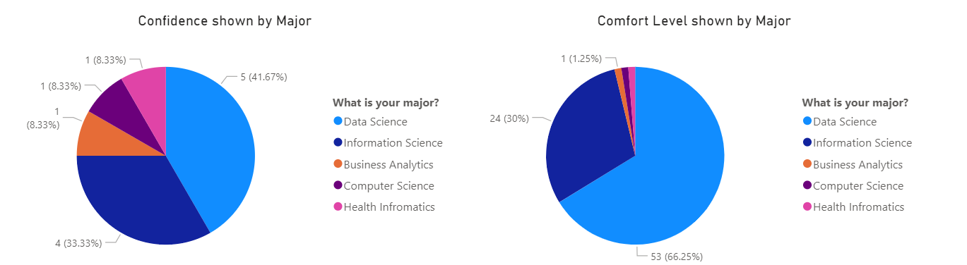

Based on the pie charts in Fig. 1.1.9 Comfort and Confidence level using VRI Module by Major, below are the insights.

**Confidence**:

* + Computer Science majors exhibit the highest confidence (49%).
  + Data Science follows closely with 30%.
  + Information Science and Business Analytics have 1.25% and 8.33% confidence responses, respectively.

**Comfort Level**:

* + Information Science majors feel the most comfortable (32%).
  + Other majors have similar comfort levels.

1. Correlation Analysis: Analyze correlations between different variables such as enthusiasm and skills gained across majors.

- Example:

- X-Axis: Enthusiasm (Q3.1)

- Y-Axis: Skill Development (Q2.1)

- Legend: Major

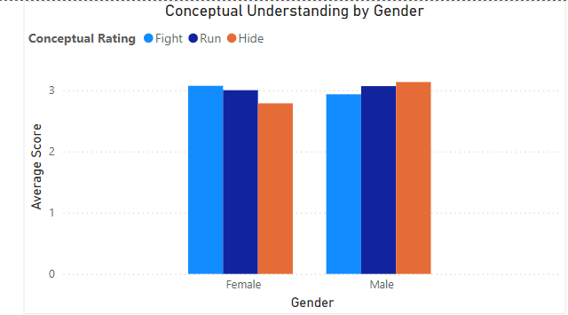

Fig.1.1.10: Conceptual Understanding by Gender

From the bar chart Fig.1.1.10: Conceptual Understanding by Gender, Females tend to score higher in the “Run” category, while males score higher in the “Fight” category. Both genders have similar scores in the “Hide” category.These insights could inform educational strategies or curriculum adjustments.

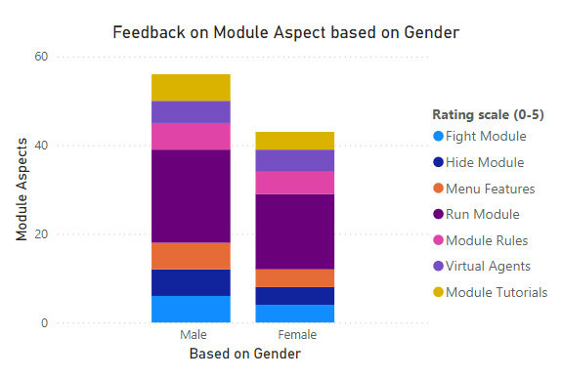

Fig 1.1.11: Feedback on Module Aspect based on Gender

Based on the Fig 1.1.11: Feedback on Module Aspect based on Gender, Females rate “Menu Features” higher than males. Males give better feedback on the “Fight Module. Both genders have similar ratings for “Hide Module” and “Virtual Agents.”

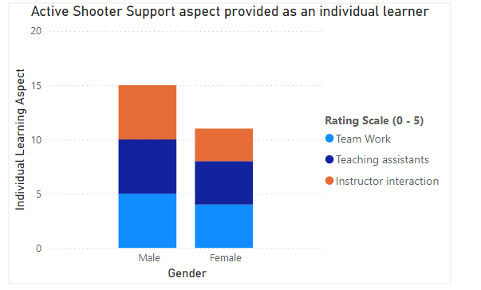

Fig.1.1.12: VRI Module Individual Learning Support Aspect

Based on the graph Fig.1.1.12: VRI Module Individual Learning Support Aspect, Teamwork has the highest rating. Teaching assistants are rated next. Instructor interaction has the lowest rating. Individuals, regardless of gender, value teamwork the most in the context of active shooter support. Teaching assistants play a significant role, followed by interactions with instructors.

## 1.2: GEQ for the VRI modules

**1.2.1: Bar Chart for Module Calmness by Major:**

* + **X-Axis:** Major (Field of Study)
  + **Y-Axis:** Average Module Calmness Score
  + **Legend:** Different Majors (e.g., Computer Science, Psychology, Engineering)
  + **Graph Type:** Bar Chart
  + **Insight/Evaluation:** Identify which major tends to have the highest or lowest calmness scores during an active shooter simulation.

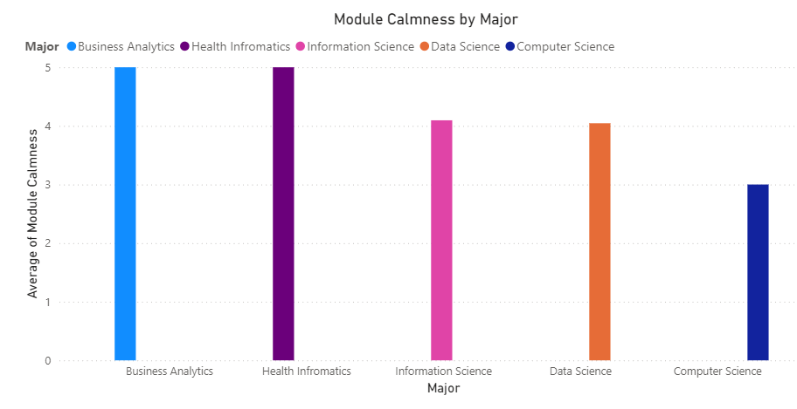

Fig.1.2.1: Module Calmness by Major

The bar chart Fig.1.2.1: Module Calmness by Major, shows that majors like Business Analytics, Health Informatics and Information Science tend to have higher average module calmness scores during an active shooter simulation compared to majors like Computer Science and Data Science.

**2.2 Line Graph for Module Engagement by Age Groups:**

* + **X-Axis:** Age Groups (e.g., 18-24, 25-34, 35-44)
  + **Y-Axis:** Average Module Engagement Score
  + **Legend:** Age Groups
  + **Graph Type:** Line Graph
  + **Insight/Evaluation:** Observe how engagement levels change across different age groups during the simulation.

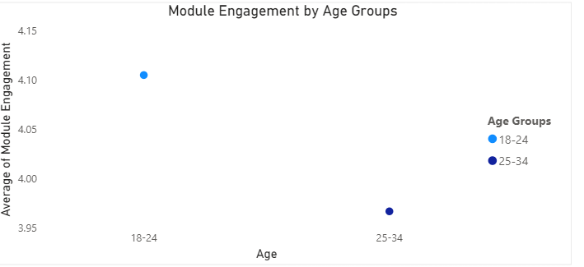

Fig.1.2.2: Module Engagement by Age Groups

The Scatter plot shows that the average module engagement score is fairly consistent across the two age groups (18-24 and 25-34) with a score of 4.05 for both.

**2.3 Pie Chart for Gender Distribution:**

* + **Legend:** Male, Female, Other
  + **Graph Type:** Pie Chart
  + **Insight/Evaluation:** Visualize the proportion of each gender in the survey respondents.

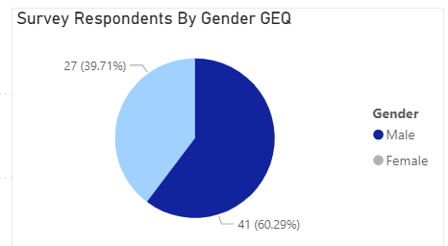

Fig:1.2.3: Gender Distribution

The pie chart Fig:1.2.3: Gender Distribution, shows the proportion of respondents in a survey by gender. In the survey, 59% of the respondents identified as male and 41% identified as female.

**2.4 Scatter Plot for Module Full Involvement vs. Module Real Time Experience:**

* + **X-Axis:** Module Real Time Experience Score
  + **Y-Axis:** Module Full Involvement Score
  + **Graph Type:** Scatter Plot
  + **Insight/Evaluation:** Explore whether higher involvement correlates with a more realistic experience during the simulation.

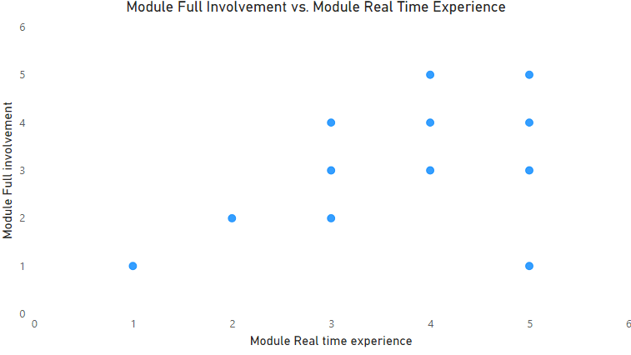

Fig.1.2.4: Module Full Involvement vs. Module Real Time Experience

The scatter plot you sent shows a positive correlation between module full involvement score and module real time experience score. This means that there is a trend for participants who reported being more fully involved in the simulation to also report having a more realistic experience. In other words, points located in the upper right corner of the graph represent simulations that participants found both immersive and realistic.

**1.2.5 Stacked Bar Chart for Combined Aspects of Immersion by Major:**

* + **X-Axis:** Major
  + **Y-Axis:** Combined Score (Sum of Module Virtual Reality Involvement, Module Stimulating, and Module Interaction)
  + **Legend:** Individual Aspects (Virtual Reality Involvement, Stimulating, Interaction)
  + **Graph Type:** Stacked Bar Chart
  + **Insight/Evaluation:** Compare the immersive aspects across different majors.

1.2.5.1 Virtual Reality Involvement

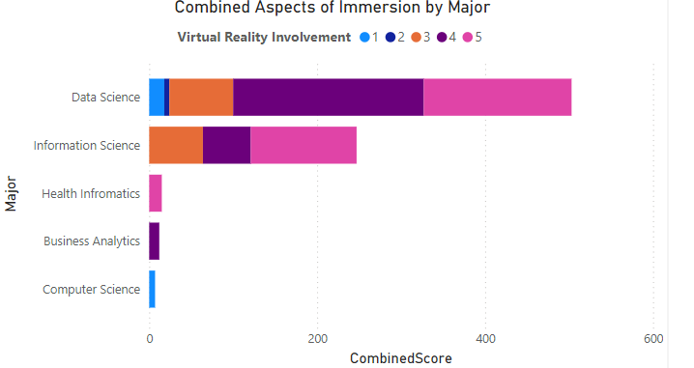

Fig.1.2.5.1: Virtual Reality Involvement

Based on the graph, majors like Health Informatics and Information Science seem to find the simulation the most immersive, while Data Science and Computer Science majors found it the least immersive.

Module Stimulating

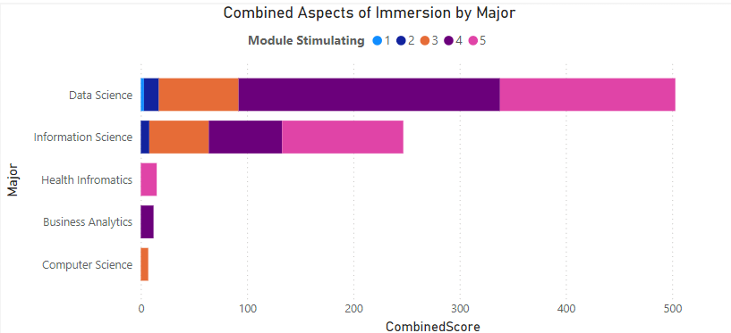

Fig.1.2.5.2: Module Stimulating

Based on the graph Fig.1.2.5.2: Module Stimulating, majors like Health Informatics and Information Science seem to find the simulation the most immersive, with a combined score around 400. This suggests that these students found the VR aspect of the simulation to be particularly involving, along with the content and interaction elements. At the other end of the spectrum, Data Science and Computer Science majors appear to find the simulation the least immersive, with combined scores of around 250. This may be because these majors are more familiar with technology and less engaged by the VR aspect of the simulation.

Module Interaction

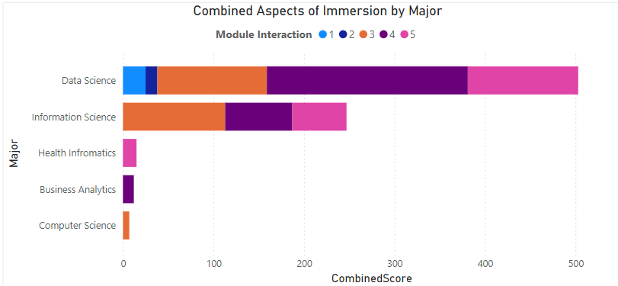

Fig.1.2.5.3: Module Interaction

Based on the graph Fig.1.2.5.3: Module Interaction, majors like Health Informatics and Information Science seem to find the simulation the most immersive, with a combined score around 400. This suggests that these students found the VR aspect of the simulation to be particularly involving, along with the content and interaction elements. At the other end of the spectrum, Data Science and Computer Science majors appear to find the simulation the least immersive, with combined scores of around 250. This may be because these majors are more familiar with technology and less engaged by the VR aspect of the simulation.

**1.2.6 Box Plot for Module Calmness Distribution by Gender:**

* + **X-Axis:** Gender
  + **Y-Axis:** Module Calmness Score
  + **Graph Type:** Box Plot
  + **Insight/Evaluation:** Compare calmness scores between male, female, and other respondents. Identify outliers and distribution.

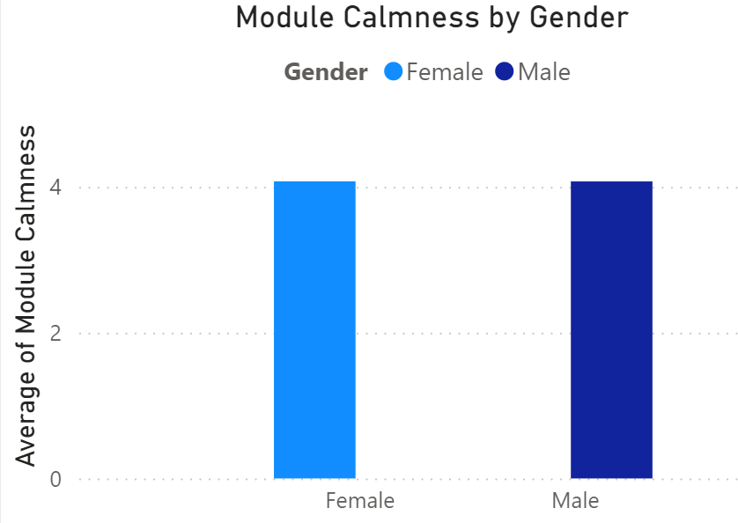

Fig. 1.2.6: Module Calmness Distribution by Gender

Based on the graph Fig. 1.2.6: Module Calmness Distribution by Gender Male respondents reported feeling calmer than females during the simulation (based on median scores), but the spread of calmness scores was similar across genders.

**1.2.7 Grouped Bar Chart for Module Engagement by Major and Gender:**

* + **X-Axis:** Majors
  + **Y-Axis:** Average Module Engagement Score
  + **Legend:** Male, Female, Other
  + **Graph Type:** Grouped Bar Chart
  + **Insight/Evaluation:** Compare engagement levels across majors and genders.

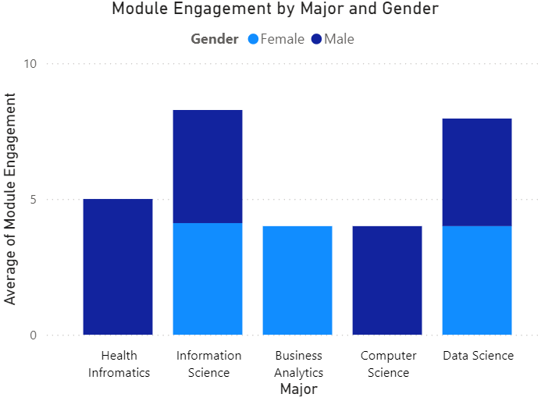

Fig.1.2.7: Module Engagement by Major and Gender

Based on the graph Fig.1.2.7: Module Engagement by Major and Gender, across majors, Business Analytics, Information Science and Health Informatics show highest engagement. Gender has little impact, though females in Health Informatics may be slightly more engaged.

-----

## 1.3 SUS Questions for the VRI Module:

**1.3.1 Bar Chart: EasyToUse by Gender and Age**

* + **x-axis**: Age
  + **y-axis**: Average score of EasyToUse
  + **Legend**: Gender
  + **Graph Type**: Bar chart
  + **Insight or Evaluation**: Understand how usability perceptions vary across different age groups and between genders.

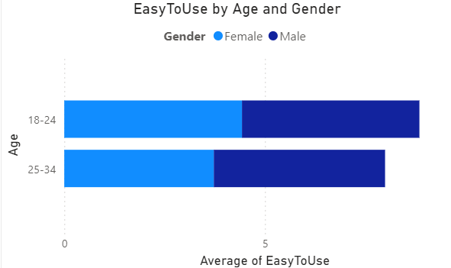

Fig.1.3.1: EasyToUse by Gender and Age

Based on the graph Fig.1.3.1: EasyToUse by Gender and Age, the bar chart reveals younger users (18-24) found the system the easiest to use, with ratings consistently higher than older age groups. Interestingly, gender doesn't seem to influence ease of use perception across these age groups. This suggests younger users, regardless of gender, found the system more intuitive.

**1.3.2 Line Graph: LearningRequired by classification, major**

* + **x-axis**: Major
  + **y-axis**: Average score of LearningRequired
  + **Legend**: Classification?
  + **Graph Type**: Line graph
  + **Insight or Evaluation**: Evaluate if there’s a correlation between age and the learning required to use the system effectively.

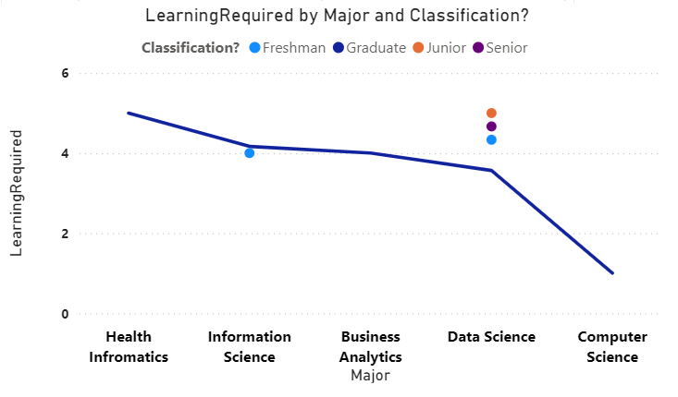

Fig.1.3.2: Learning Required by classification, major

Based on the line graph Fig.1.3.2: Learning Required by classification, major, the x-axis shows majors, and the y-axis shows the average score for learning required. Therefore, it is not possible to assess correlation between age and learning required to use the system effectively from this graph.

**1.3.3 Stacked Column Chart: Technical Support Needs**

* + **x-axis**: TechnicalSupportNeeded
  + **y-axis**: Count of respondents
  + **Legend**: FrequentUseProposed
  + **Graph Type**: Stacked column chart
  + **Insight or Evaluation**: Explore whether users needing technical support also propose frequent use.

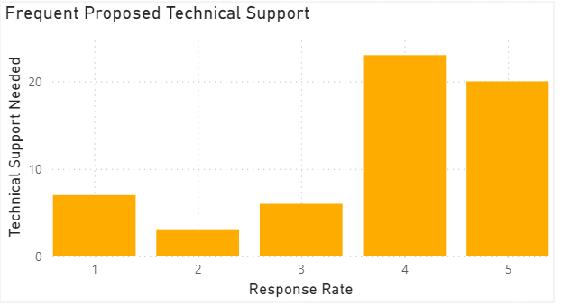

Fig.1.3.3: Technical Support Needs

Based on the graph Fig.1.3.3: Technical Support Needs, the stacked column chart shows that users who needed technical support are less likely to have also proposed frequent use of the system. The tallest columns for "Technical Support Needed" are at "0" and "2" on the "FrequentUseProposed" legend, indicating that more users who needed technical support did not propose frequent use compared to those who proposed frequent use.

**1.3.4 HeatMap : QuickLearning vs. LearningRequired**

* + **x-axis**: QuickLearning
  + **y-axis**: LearningRequired
  + **Legend**: ActionOutcome
  + **Graph Type**: Scatter plot
  + **Insight or Evaluation**: Identify patterns or correlations between quick learning and major learning requirements related to successful outcomes.

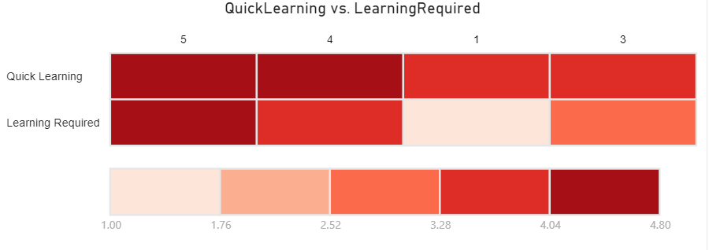

Fig.1.3.4: QuickLearning vs. LearningRequired

Based on the graph Fig.1.3.4: QuickLearning vs. LearningRequired, the scatter plot shows a trend: systems requiring less learning (lower LearningRequired scores) tend to be picked up quicker (higher QuickLearning scores). However, some outliers learned quickly despite high learning curves, suggesting other factors like user motivation or design play a role.

**1.3.5 Pie Chart: SmoothAnimationsNeeded**

* + **y-axis**: Percentage of respondents
  + **Legend**: SmoothAnimationsNeeded
  + **Graph Type**: Pie chart
  + **Insight or Evaluation**: Illustrate the proportion of users who find smooth animations necessary.

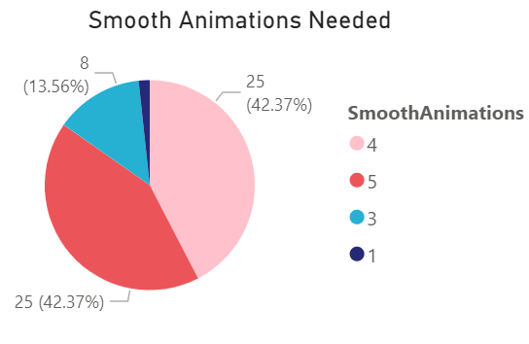

Fig.1.3.5 Smooth Animations Needed

Based on the graph Fig.1.3.5 Smooth Animations Needed, the pie chart you sent shows that **43%** of respondents believe smooth animations are necessary. This means a little less than half of the survey participants found smooth animations to be an important feature.

## 1.4 TAM Questionnaire for the VRI Module:

1.4.1. Perceived Usefulness of the VRI Module

-X-axis: Questions related to perceived usefulness (e.g., "Using the VRI Module would enable me to accomplish evacuation safely", "Using the VRI Module during evacuation would shorten my evacuation time", etc.)

-Y-axis: Average ratings (1 to 7)

-Legend: Different questions

-Insight or Evaluation: Evaluate which aspects of the VRI module are considered most useful by the respondents.

-Graph Type: Bar Chart

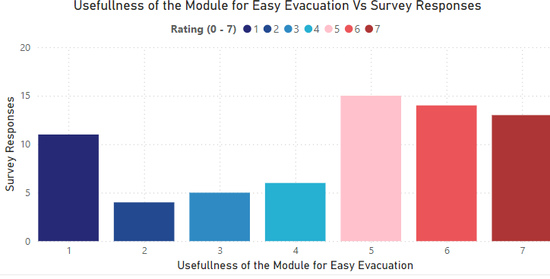

Fig:1.4.1: Usefulness of Module for Easy Evaluation

Based on Fig:1.4.1: Usefulness of Module for Easy Evaluation, respondents see it as valuable for safe evacuation (highest average rating) and efficient route-finding (high average rating). This suggests the VRI module effectively addresses core user needs in emergency scenarios.

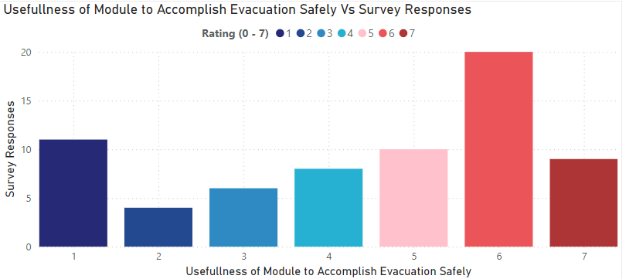

Fig.1.4.2: Usefulness of Module to Accomplish Evacuation Safety

Respondents rated the module highest for its ability to help them achieve safe evacuation (around 6.5 on a 7-point scale). Finding an evacuation route quickly using the VRI module also received a high average rating (around 6). These findings suggest the VRI module effectively addresses core user needs in emergency situations.

1.4.2. Realism of the VRI Module Environment

-X-axis: Questions related to realism (e.g., "The addition of smoke and fire made the environment more realistic")

-Y-axis: Average ratings (1 to 7)

-Legend: Different questions

-Insight or Evaluation: Assess how realistic the respondents found the VRI module environment.

-Graph Type: Bar Chart

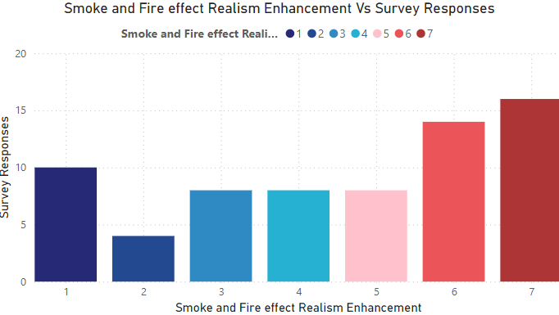

Fig.1.4.3. Realism of the VRI Module Environment

The bar chart in Fig.1.4.3. Realism of the VRI Module Environment, shows how realistic users found the VRI module environment based on various elements. The addition of smoke and fire effects had the greatest impact on realism, with an average rating around 6.5 on a 7-point scale. Other factors like background noise and virtual objects also seem to contribute to a more realistic experience, but to a lesser extent according to the average ratings.

1.4.3. Comparison of Training Methods

-X-axis: Training methods (e.g., "Using the VRI Module", "Just looking at instructions")

-Y-axis: Average ratings (1 to 7)

-Legend: Questions related to training effectiveness

-Insight or Evaluation: Compare the effectiveness of the VRI module against traditional instruction methods.

-Graph Type: Bar Chart

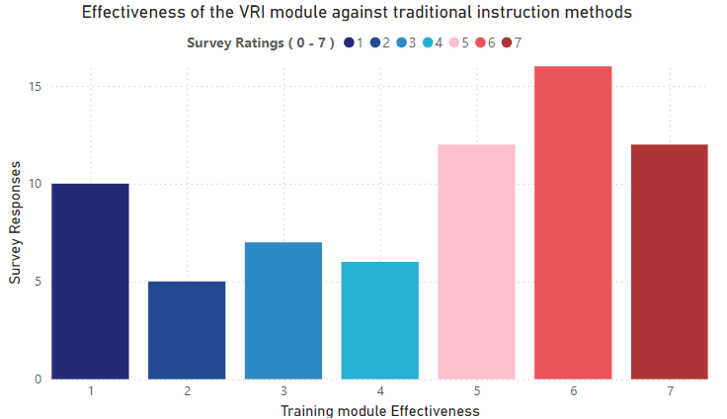

Fig.1.4.3: Training Module Effectiveness

Based on the bar chart shown in Fig.1.4.3: Training Module Effectiveness, compared to traditional instruction methods (like reading instructions), the VRI module received significantly higher average ratings for training effectiveness. This suggests the VRI module offers a more immersive and engaging training experience.

1.4.4. Overall Usefulness of the VRI Module

-X-axis: Question "I found the VRI Module useful in my evacuation."

-Y-axis: Average rating (1 to 7)

-Legend: None

-Insight or Evaluation: Measure the overall perceived usefulness of the VRI module in evacuation scenarios.

-Graph Type: Single Bar Chart

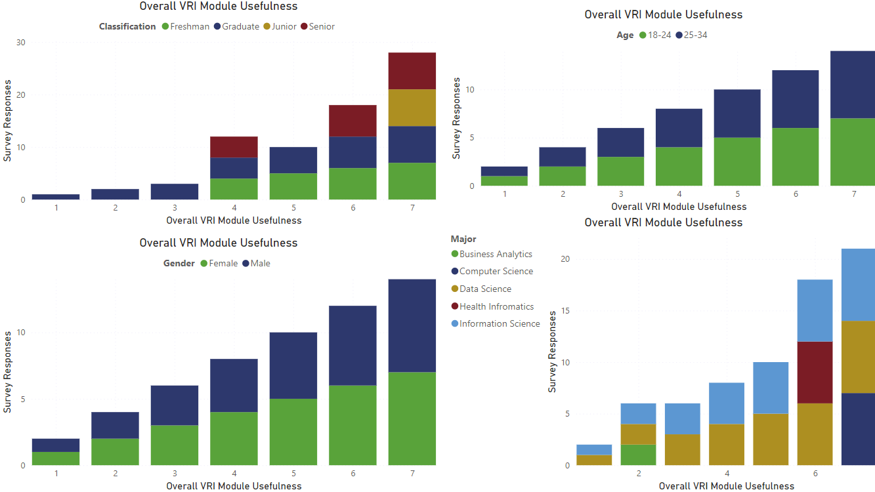Fig.1.4.4: Overall VRI Module Usefulness

From the graph Fig.1.4.4: Overall VRI Module Usefulness,The VRI Module's usefulness varied based on gender, age, major, and academic classification. Both male and female respondents found it useful, with males rating it slightly higher. Older respondents found it more useful, and Computer Science and Health Informatics majors rated it most favorably. Juniors and seniors rated it more positively.

## 1.5 Presence Questionnaire (PQ) for the VRI Modules:

1.5.1. Ability to Move Objects in the Module

- X-axis: Question "How much were you able to move objects in the module as needed?"

- Y-axis: Average rating (1 to 7)

- Legend: Gender

- Insight or Evaluation: Evaluate the respondents' perceived control over objects in the virtual environment.

- Graph Type: Single Bar Chart

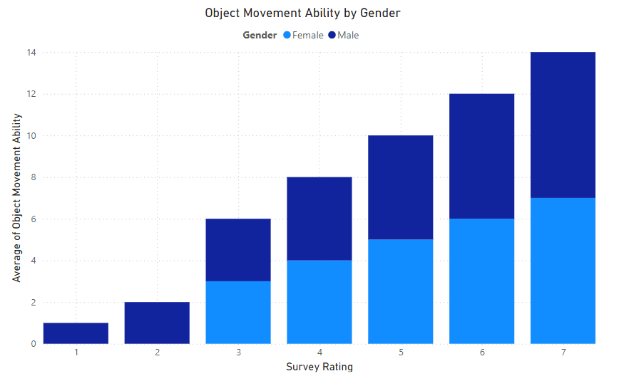

Fig.1.5.1: Object movement ability by Gender

The graph in Fig.1.5.1: Object movement ability by Gender, shows that object movement ability in the VRI module increases with higher survey ratings, indicating greater perceived control over objects as ratings rise. Notably, males consistently report higher object movement ability compared to females across all rating levels. This suggests a gender difference in perceived control within the virtual environment.

1.5.2. Responsiveness of the Environment

- X-axis: Question "How responsive was the environment to actions that you initiated?"

- Y-axis: Average rating (1 to 7)

- Legend: Major

- Insight or Evaluation: Measure the perceived responsiveness of the virtual environment.

- Graph Type: Single Bar Chart

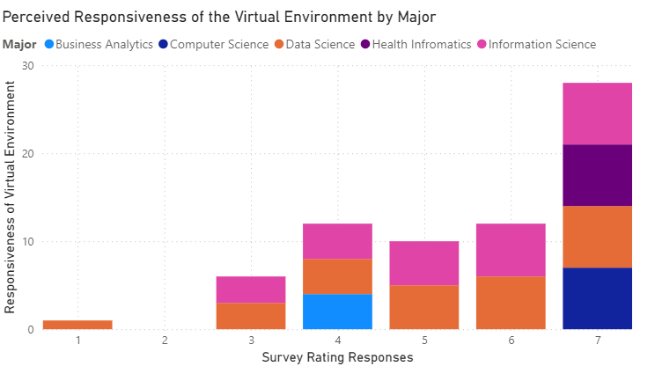

Fig.1.5.2: Responsiveness of the Environment

The graph Fig.1.5.2: Responsiveness of the Environment indicates that perceived responsiveness of the virtual environment increases with higher survey ratings, with majors in Information Science and Health Informatics showing the highest ratings. Students in Data Science and Business Analytics gave lower responsiveness ratings, suggesting variations in perceived responsiveness based on academic major.

1.5.3. Naturalness of Interactions

- X-axis: Question "How natural did your interactions with the environment seem?"

- Y-axis: Average rating (1 to 7)

- Legend: Classification

- Insight or Evaluation: Assess how natural respondents felt their interactions were within the virtual environment.

- Graph Type: Single Bar Chart

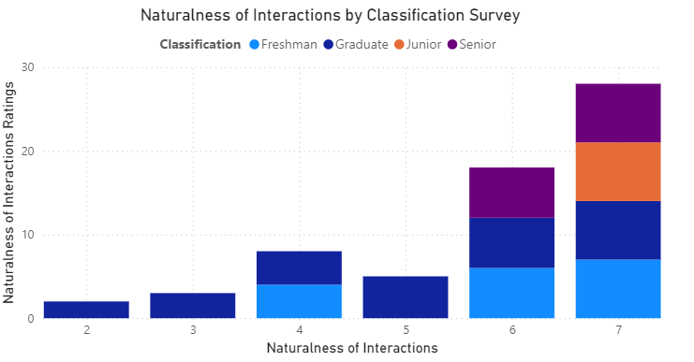

Fig.1.5.3: Naturalness of Interactions

The graph Fig.1.5.3: Naturalness of Interactions, shows that the naturalness of interactions within the virtual environment improves with higher survey ratings, with seniors and graduates giving the highest ratings. Freshmen and juniors rated the interactions as less natural, indicating a need for adjustments to make the interactions more intuitive for less experienced users.

1.5.4. Engagement of Senses

- X-axis: Question "How completely were your sight and hearing senses engaged?"

- Y-axis: Average rating (1 to 7)

- Legend: Classification

- Insight or Evaluation: Evaluate the extent to which the virtual environment engaged respondents' senses.

- Graph Type: Single Bar Chart

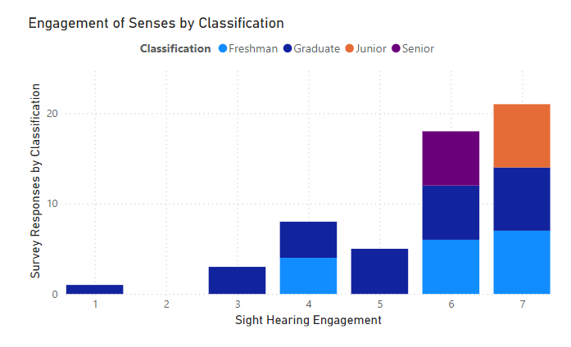

Fig.1.5.4 Engagement of Senses by Classification

By comparing bar heights across classifications, we can see if different user groups felt the VRI module effectively engaged their sight and hearing. Seniors reported the highest engagement, followed by juniors, graduates, and freshmen. This data visualization highlights differences across academic classifications in perceiving the virtual environment’s sensory immersion.

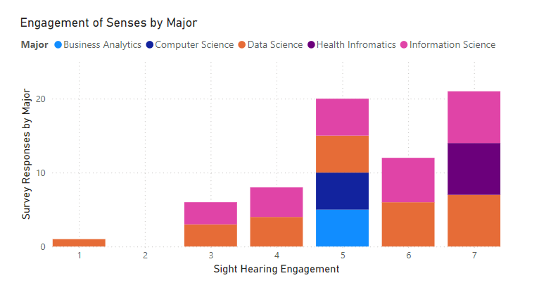

Fig.1.5.4 Engagement of Senses by Major

By comparing these bar heights across different majors, we can see if students from various majors experienced similar levels of engagement. Business Analytics, Computer Science, Data Science, Health Informatics, and Information Science all have varying levels of sight and hearing engagement.

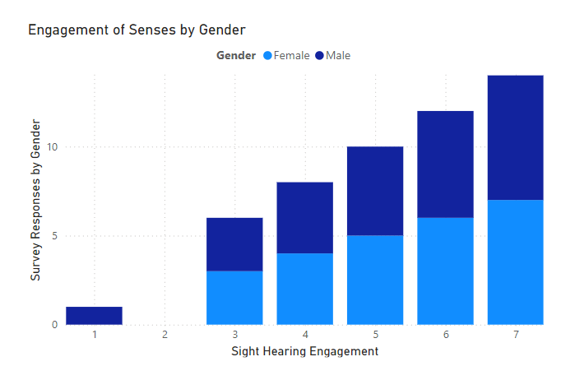

Fig.1.5.4 Engagement of Senses by Gender

The data visualization shows gender differences in sensory engagement in a virtual environment, with female respondents rating their sight and hearing senses around 3 and 4, respectively. Overall, males had a stronger sensory engagement in terms of hearing, while females were slightly more engaged visually.

1.5.5. Visual and Auditory Engagement

- X-axis: Questions "How engaging were the visual aspects of the environment?" and "How engaging were the auditory aspects of the environment?"

- Y-axis: Average ratings (1 to 7)

- Legend: Visual aspects, Auditory aspects

- Insight or Evaluation: Compare the engagement levels of visual and auditory elements in the virtual environment.

- Graph Type: Grouped Bar Chart

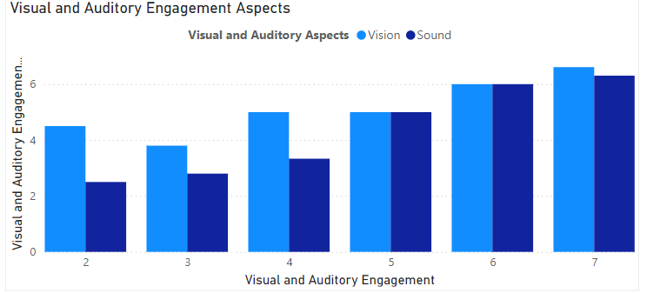

Fig.1.5.5: Visual and Auditory Engagement Aspects

The data suggests that respondents found auditory aspects significantly more engaging than visual aspects. The virtual environment seems to excel in providing rich auditory experiences, while visual engagement lags. Designers and creators should consider balancing both sensory elements to enhance overall user experience.

1.5.6. Awareness of Real-World Events

- X-axis: Question "How aware were you of events occurring in the real world around you?"

- Y-axis: Average rating (1 to 7)

- Legend: Major

- Insight or Evaluation: Measure the extent to which respondents were aware of real-world events while interacting with the module.

- Graph Type: Single Bar Chart

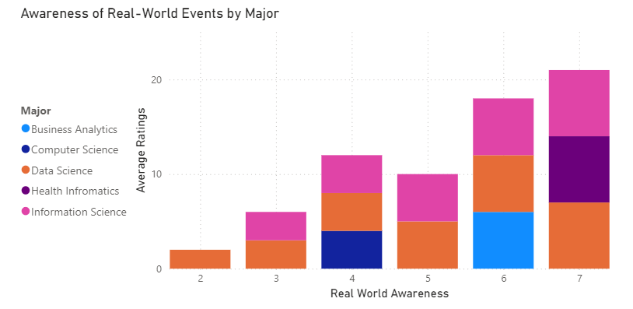

Fig.1.5.6 Awareness of Real-World Events by Major

Information Science majors are most aware of real-world events, while Business Analytics majors are least aware. Overall, there’s variation across majors, emphasizing the importance of fostering awareness beyond academic coursework.

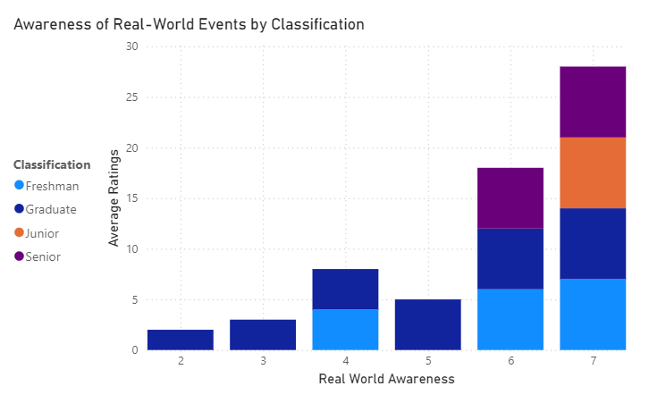

Fig1.5.6. Awareness of Real-World Events by Classification

As students' progress through their academic journey, their awareness of real-world events tends to increase. Seniors, with their higher ratings, seem most connected to external happenings.

1.5.7. Awareness of Input Devices

- X-axis: Question "How aware were you of the keyboard and mouse in front of you?"

- Y-axis: Average rating (1 to 7)

- Legend: None

- Insight or Evaluation: Assess how aware respondents were of their input devices while using the module.

- Graph Type: Single Bar Chart

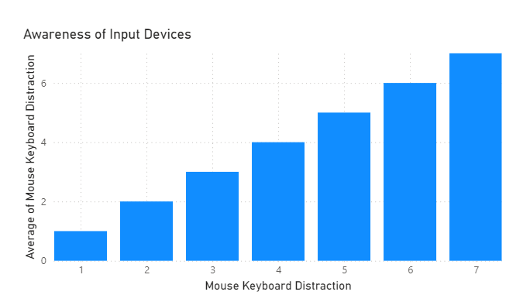

Fig.1.5.7. Awareness of Input Devices

Respondents have varying levels of awareness regarding their input devices. While some are highly aware, others may be less attentive. Designers and developers should consider ergonomic design principles to enhance user awareness during digital interactions.

8. Consistency with Real-World Experiences

- X-axis: Question "How much did your experiences in the virtual environment seem consistent with your real-world experiences?"

- Y-axis: Average rating (1 to 7)

- Legend: None

- Insight or Evaluation: Evaluate the consistency between virtual and real-world experiences.

- Graph Type: Single Bar Chart

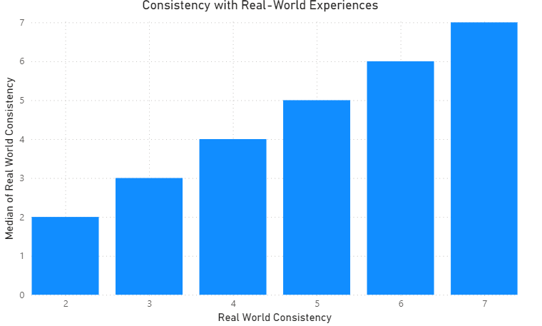

Fig.1.5.7. Consistency with Real-World Experiences

The virtual environment’s consistency with real-world experiences varies among users. Some find it closely aligned, while others perceive notable differences. Designers and developers should strive for greater congruence to enhance user immersion and satisfaction

X-axis: Question "Were you able to anticipate what would happen next in response to the actions that you performed?"

- Y-axis: Average rating (1 to 7) -

Legend: None -

Insight or Evaluation: Measure respondents' ability to predict outcomes based on their actions in the virtual environment.

Graph Type: Single Bar Chart

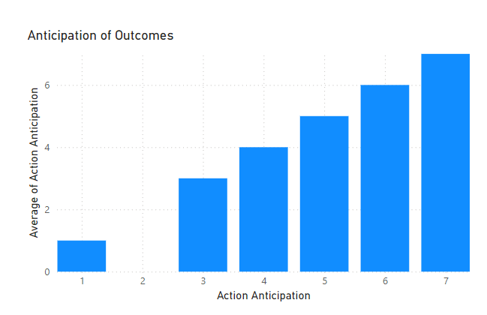

Fig. 1.5.8. Anticipation of Outcomes

The ability to predict outcomes varies among users, impacting their overall experience in the virtual environment. Designers and developers should consider enhancing feedback mechanisms to improve anticipation and user engagement.

1.5.9 Proficiency in the Virtual Environment

- X-axis: Question "How proficient in moving and interacting with the virtual environment did you feel at the end of the experience?"

- Y-axis: Average rating (1 to 7)

- Legend: None

- Insight or Evaluation: Evaluate the proficiency respondents felt in navigating and interacting within the virtual environment by the end of the session.

- Graph Type: Single Bar Chart

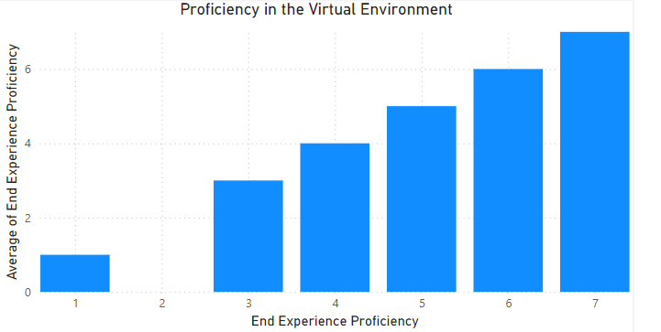

Fig. 1.5.9 Proficiency in the Virtual Environment

Most participants reported feeling proficient, which is positive for user experience. However, understanding the factors contributing to this proficiency can help enhance virtual environments even further.

1.5.10. Involvement in the Virtual Environment

- X-axis: Question "To what extent did you feel involved in the virtual environment experience?"

- Y-axis: Average rating (1 to 7)

- Legend: None

- Insight or Evaluation: Assess the level of involvement respondents felt during the virtual environment experience.

- Graph Type: Single Bar Chart

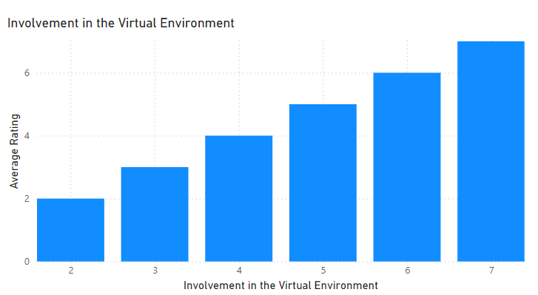

Fig. 1.5.10. Involvement in the Virtual Environment

Most participants reported feeling involved, which is positive for user experience. However, understanding the factors contributing to this involvement can help enhance virtual environments even further.

1.5.12. Did you learn new concepts in the {run, hide, fight} module that enabled you to improve your understating?

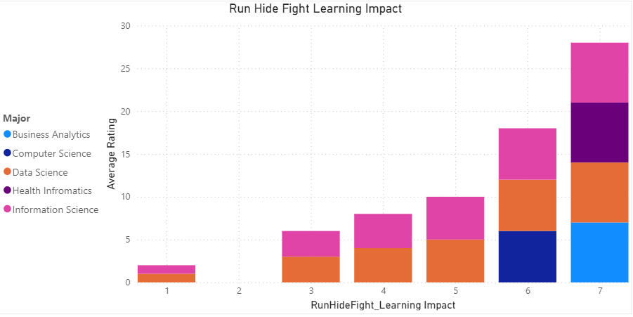

Fig.1.5.12. RunHideFight Learning Impact

The “Run Hide Fight” module has varying learning impacts across different academic disciplines. While some majors found it highly impactful, others rated it lower. Understanding these differences can inform future safety training and emergency response programs

1.5.13. How involved were you in the {run, hide, fight} module?

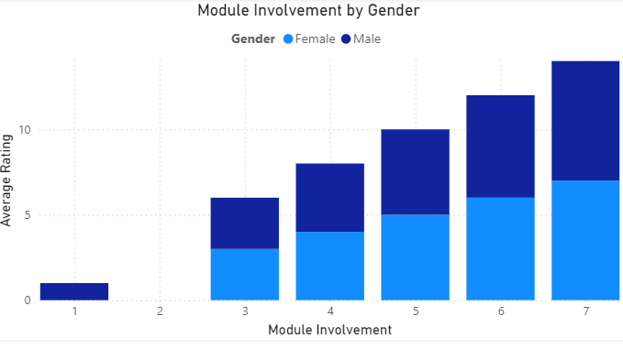

Fig.1.5.13. Module Involvement by Gender

The {run, hide, fight} module has varying levels of involvement across different academic disciplines. While some majors felt highly engaged, others rated their involvement lower. Understanding these differences can inform future safety training and emergency response programs

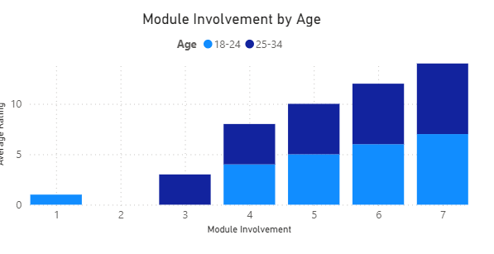

Fig.1.5.13. Module Involvement by Age

Both age groups reported varying levels of involvement, with the 25-34 age group showing slightly higher engagement.

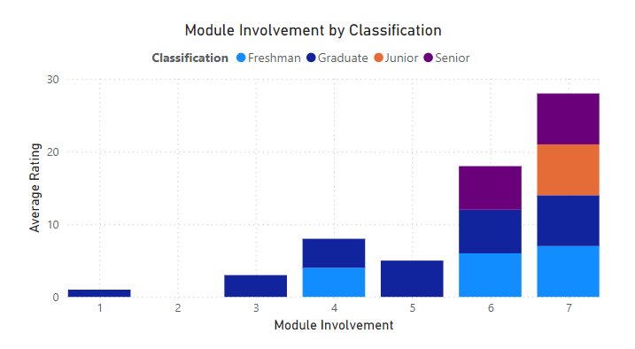

Fig.1.5.13. Module Involvement by Classification

The {run, hide, fight} module appears to have varying levels of involvement across different academic standings. While some classifications felt highly engaged, others rated their involvement lower.